**Convert Text to Upper or Lower Case**

This is an Example to Convert Text to Upper or Lower Case in React Native. To do this we will use the string property toUpperCase() and toLowerCase() which will convert your text to Upper case and lower case respectively.

Convert Text to Upper Case Using

var uppercasetext = text.toUpperCase();//To convert Upper Case

Convert Text to Lower Case Using

var lowercasetext = text.toLowerCase();//To convert Lower Case

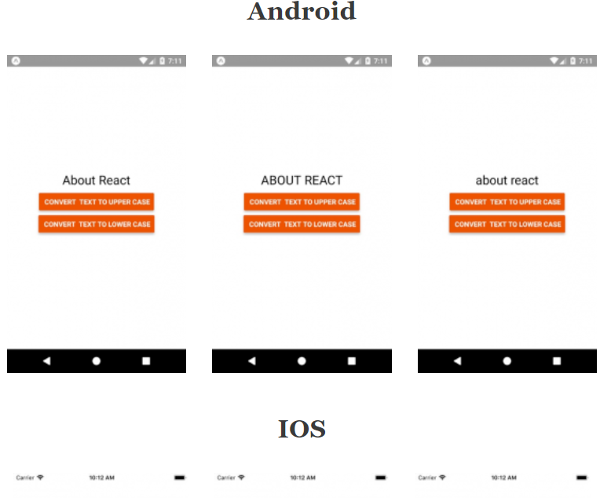

/*This is an Example to convert text in upper or lowercase on Button Click in React Native*/

import React, { Component } from 'react';

//import react in our project

import { StyleSheet, Text, View, Button } from 'react-native';

export default class App extends React.Component {

constructor() {

super();

this.state = {

defaultText: 'About React',

};

}

convertTextToUpperCase = () => {

var text = this.state.defaultText;

var uppercasetext = text.toUpperCase();//To convert Upper Case

this.setState({ defaultText: uppercasetext });

};

convertTextToLowerCase = () => {

var text = this.state.defaultText;

var lowercasetext = text.toLowerCase();//To convert Lower Case

this.setState({ defaultText: lowercasetext });

};

render() {

return (

<View style={styles.MainContainer}>

<Text style={styles.TextStyle}> {this.state.defaultText} </Text>

<View style={{ marginTop: 10 }}>

<Button

title=" Convert Text To Upper Case"

onPress={this.convertTextToUpperCase}

color="#606070"

/>

</View>

<View style={{ marginTop: 10 }}>

<Button

title=" Convert Text To Lower Case"

onPress={this.convertTextToLowerCase}

color="#606070"

/>

</View>

</View>

);

}

}

const styles = StyleSheet.create({

MainContainer: {

flex: 1,

justifyContent: 'center',

alignItems: 'center',

},

TextStyle: {

fontSize: 25,

textAlign: 'center',

},

});